Additional report
- NutriTrack workflow Integration
Stage | Action & Integration | Tool Function
Clinical Assessment | The physician evaluate patient and sets specific energy and protein targets.(1) | Prescription Input: Clinical data and targets are synced or manually entered into the NutriTrack professional interface.
Feed Customization | Clinicians discuss with caregivers and select the formula components. | Auto-Calculation: AI calculates the precise volume and rate required to meet the prescribed
Caregiver Onboarding | The caregiver receives a QR code or link to access the patient-specific profile on the NutriTrack app. | User Mapping: Connects the professional prescription to the caregiver’s daily task list.
Daily Administration | Caregivers log each feed session (volume, time, and any complications like gastric residual volume). | Smart Reminders: The app sends push notifications to ensure feeding schedules are maintained, reducing the risk of underfeeding.
Real-Time Tracking | The app visualizes the "Nutritional Gap" (Actual vs. Prescribed Intake). | Compliance Monitoring: AI flags if the patient is falling below 60% of their target(1)
Remote Feedback | The recorded data is summarized into a weekly report for the physician’s review. | Data Continuity: Enables informed adjustments during follow-up visits without relying solely on manual diaries

- Caregiver-Centric Design
We have updated the NutriTrack dashboard to include how to use infographics and add some infographic/icon at the input and output data ensuring that the application is more accessible and easier for caregivers to interpret.

“How to use” tab
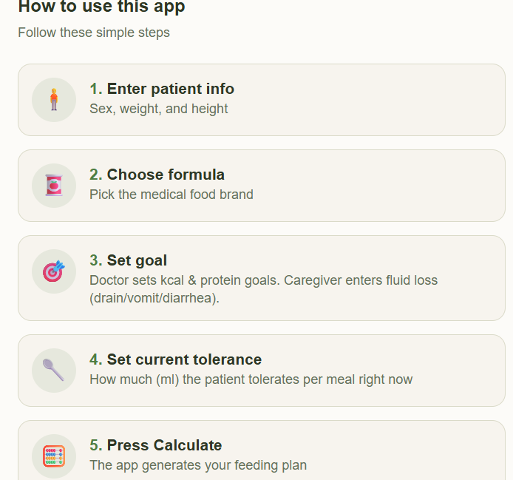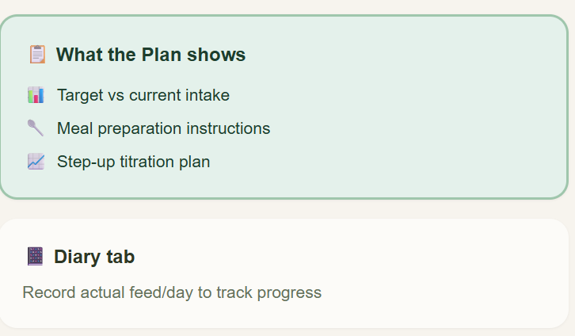

Add infographic in other tab
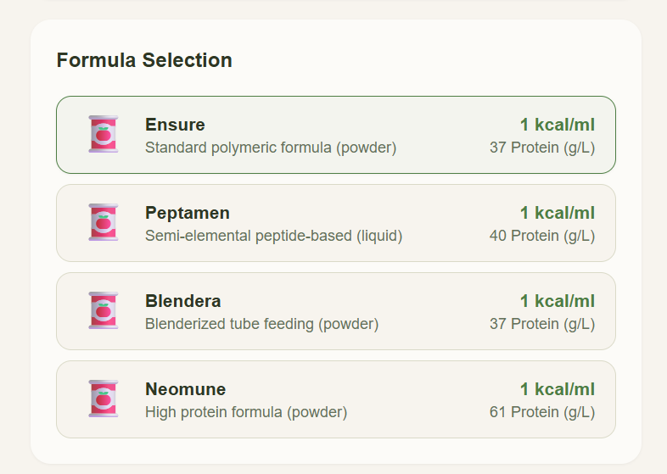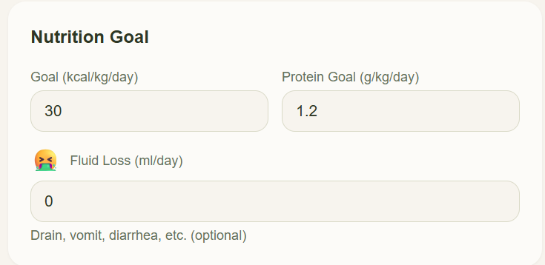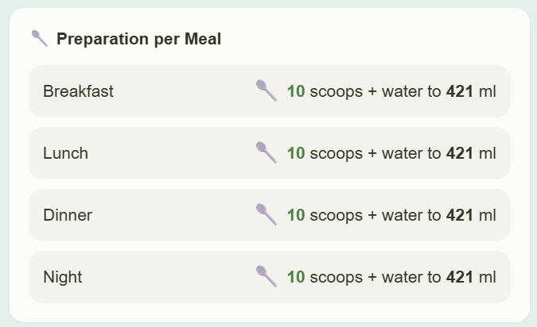
- Competitor Analysis
Comparing NutriTrack to the existing Tubie application reveals a distinct difference in focus: NutriTrack’s specialized clinical utility. While general apps like Tubie serve as long-term "logbooks" for stable patients, NutriTrack is designed as a dynamic intervention tool for the critical transition period.

Clinical Differentiation: The "Adaptation Phase"
NutriTrack fills a critical gap in the patient journey that current market solutions overlook:
- The "New User" Learning Curve: For caregivers managing a tube for the first time, the complexity of calculating feed rates can be overwhelming. NutriTrack simplifies this with guided infographics and automated calculations.
- The Oncology Challenge: Patients undergoing chemotherapy often suffer from treatment-induced side effects like mucositis or delayed gastric emptying. They rarely tolerate "full feeds" immediately.
Specification Comparison
- Precision Titration: Unlike Tubie, which tracks what was given, NutriTrack calculates what should be given next based on the patient's real-time tolerance, allowing for a safer "low and slow" approach to meeting nutritional targets
- Clinical Titration vs. Manual Calculation
Tubie provides tools like an "Interval Timer" and "Pump Speed Calculator" to help users manually set their hardware (2). NutriTrack goes a step further by integrating clinical goals—it doesn't just calculate speed; it calculates the required dose based on the patient's nutritional gap and physiological needs.
- Fluid Management
NutriTrack’s ability to "add fluid loss and adjust daily" is a unique differentiator. Standard apps like Tubie or Tubie Tracker allow for logging volumes, but they do not typically calculate the compensatory fluids needed if a patient has high gastric residual volume or diarrhea (3)
- Diary and Logistics
Tubie is very strong in "supply management," offering reminders for when feeding sets or tubes expire(2) NutriTrack focuses its diary more on clinical outcomes (Nutritional Gap, compliance, and clinical complications) rather than hardware inventory.

- TAM/SAM/SOM
SOM : King Chulalongkorn Memorial Hospital patients with enteral feeding
SAM : Home-base tube feeding in Bangkok
TAM : Thailand patients with enteral feeding

- Strategic Partnerships
Strategic Partnerships with Medical Food Brands
  - The "Direct-to-Home" Logistics Integration

The Strategy: Integrate a "One-Click Order" button within the app. When the clinician prescribes a specific formula (e.g., a high-protein formula for a post-surgery cancer patient), the caregiver can order it directly through the app.

The Function: The app calculates the Inventory Forecast. Based on the titration dose, NutriTrack knows exactly when the caregiver will run out of stock and sends a notification: "Your formula will last for 3 more days. Would you like to re-order now for home delivery?"

Benefit: The brand gains a recurring revenue stream and high customer loyalty, while the caregiver avoids the stress of running out of supplies.

  - Data-Driven "Adherence Reports" for Brands
The Strategy: Provide anonymized, aggregated data to the brand regarding how patients tolerate their formulas during the "Adaptation Phase."
The Function: A dashboard for the brand's medical affairs team showing, for example: "80% of oncology patients using [Product X] reached their full-feed target within 5 days using NutriTrack titration."
Benefit: Brands can use this clinical "real-world evidence" to market their products to more hospitals and doctors.

- Business details:
6.1Pricing strategy
1. The "Hospital-as-a-Service" Subscription (B2B)
- Instead of charging patients directly, the hospital pays a License Fee to integrate NutriTrack into their discharge and home-care workflow.
- Annual monthly subscription based on the number of active
- Caregivers and patients receive Free Access via a hospital-provided activation code at the point of discharge.
2.The "Brand Sponsorship" Revenue (B2B)
- Partnering with Medical Food brands (e.g., Nestlé, Abbott)
- Brands pay to have their product catalog pre-loaded and featured as the "Preferred Option" in the calculator.
- NutriTrack takes a 3–5% referral fee on every order placed through the app’s "Buy Now" button for home delivery.
- Brands pay for access to anonymized, aggregated "Tolerance & Adherence" reports to understand how their products perform in real-world oncology cases.
  - Go-to-market
Market Opportunity
The Thai enteral feeding devices market is projected to reach $62.4 million in 2025, growing at a CAGR of 6.1% through 2033. (4) Oncology nutrition is one of the fastest-growing sub-segments. With approximately 55% of enteral products distributed through hospital pharmacies. (5) NutriTrack’s value proposition is its clinical decision support during high-sensitivity treatments like foregut cancer cases or patients ongoing chemotherapy.
Strategic Go-to-Market Phases
Clinical Validation & "The Chula Pilot" : run a pilot study focusing on "Time to Target Feed" (how quickly patients reach their goal with vs. without the app).
B2B Hospital Partnerships : Offer the app as a free value-add to the Nutrition Support Teams
Corporate Sponsorship & Commercial Scale : Partner with brands and activate the in-app ordering system.
Financial & Pricing Architecture
Hospital Revenue: A Tiered Subscription Plan
Sponsorship Revenue: Tiered placement fees for medical food brands.
Transaction Revenue: 3–5% commission on formula sales via the D2H integration.

Reference
- Arends, J.(2017). ESPEN guidelines on nutrition in cancer patients. Clinical Nutrition, 36(1), 11–48. https://doi.org/10.1016/j.clnu.2016.07.015
- Linden, L. E. C. (2025). Tubie - Tube feeding companion [Mobile app]. App Store. https://apps.apple.com/nz/app/tubie/id6502291944
- Tubie Tech. (n.d.). Feeding calculator: Volume to rate and rate to TAMvolume. https://tubietech.com/pages/feeding-calc
- Grand View Research. (2025). Thailand enteral feeding devices market size & outlook, 2033. Horizon Databook.
- Future Market Insights. (2026). Enteral nutrition market: Global market analysis report - 2036.

