OonJai Breast Partners
AI-Guided Breast Cancer Education & Real-World Evidence Platform
Revised Project Report | Chayanee Sae-lim, MD | Clinical Science Ph.D. Program, Chulalongkorn University
Revised in response to Professor feedback | May 2026

1. Introduction
Breast cancer remains one of the most prevalent malignancies worldwide, creating substantial challenges in patient understanding, treatment adherence, and long-term survivorship care. Despite advancements in systemic therapy, targeted treatment, and precision surgery, many patients experience anxiety and confusion regarding treatment pathways.
OonJai Breast Partners is a dual-purpose digital health platform that (1) delivers personalized, guideline-aligned breast cancer education through an AI-powered chatbot integrated with LINE Official Account, and (2) generates structured real-world evidence through longitudinal quality-of-life (QOL) and survival outcome registries. This revised report incorporates faculty feedback to strengthen the user journey analysis, business model clarity, revenue sustainability, content partnership definition, and competitive positioning.

2. User Journey and Value Proposition Analysis (Revised)
The primary target users include breast cancer patients and caregivers requiring personalized treatment education. Secondary stakeholders include oncologists, researchers, and pharmaceutical partners interested in real-world outcome analytics.
The platform’s value proposition centers on delivering guideline-aligned educational content tailored to patient clinical profiles, such as disease stage and molecular subtype. By integrating curated multimedia content, interactive learning modules, and treatment pathway visualization, the platform reduces uncertainty and improves health literacy. (Figire 1)
Simultaneously, structured quality-of-life questionnaires and survival status reporting generate longitudinal datasets that can inform research, policy development, and precision oncology strategies.

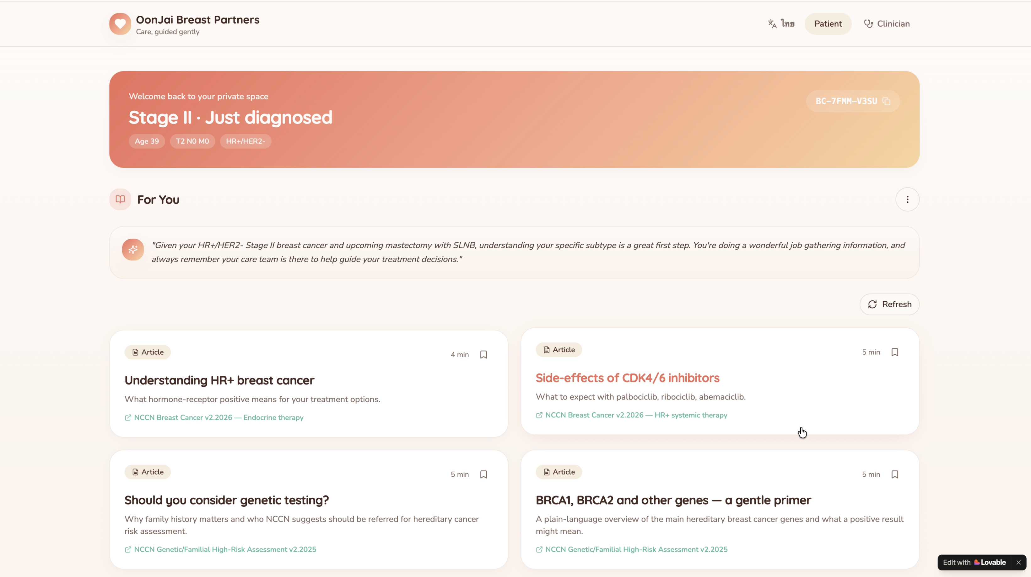
Figure 1 An example of webpage that linked to line official account

2.1 Existing User Journey — Pain Points Identified
The following table maps the patient journey across five clinical stages, contrasting the current standard experience with the OonJai-enhanced pathway, and defining quantitative success metrics for each stage.

Stage | Diagnosis | Treatment Planning | Active Treatment | Survivorship | Long-Term Follow-up
Current Experience | Overwhelming info, anxiety, ↑ misinfo from internet | Long clinic wait, limited time with doctor | Unclear SE management, poor adherence ~60% | Unstructured follow-up, fear of recurrence | No structured QOL monitoring
With OonJai | Personalized content by subtype within 24hr | AI pathway visualization, Q&A prep tool | Gamified adherence tracker, chatbot SE support | Curated survivorship content, community | Automated QOL surveys, outcome registry
Key Metric | Anxiety score (GAD-7) ↓ target 30% | Decision conflict scale ↓ 25% | Adherence rate target ≥80% (vs baseline ~60%) | Recurrence fear scale ↓ 20% | QOL data capture rate target ≥70%

2.2 Where OonJai Intervenes — Key Value-Add Points
Critical Intervention Points
Diagnosis stage: Immediate anxiety reduction through personalized content delivered within 24 hours of registration, reducing reliance on unverified internet sources (target: GAD-7 anxiety score reduction of 30%).
Treatment adherence: Gamified reminders and chatbot support targeting adherence rate improvement from ~60% baseline to ≥80%, a gap well-documented in Thai oncology literature.
Data collection: Automated QOL surveys (FACT-B, EQ-5D) with target ≥70% completion rate, generating a registry with research and commercial value.

3. Phased Business Model (Revised)
The business model is restructured into two distinct phases aligned with the medical innovation and regulatory lifecycle.

Phase 1: Research Phase (Year 1–2)
Phase 1 Overview
Objective: Establish clinical validity, build the patient registry, and generate IRB-approved evidence.

Key Activities:
- IRB submission and approval (Chulalongkorn University / KCMH Ethics Committee)
- Enroll pilot cohort of 100–300 breast cancer patients at KCMH
- Collect longitudinal QOL data (FACT-B), survival status, and treatment adherence metrics
- Validate AI content personalization accuracy vs. NCCN/ESMO guidelines (target: ≥90% alignment)
- Apply for Health Systems Research Fund (HSRI) and NSTDA grants
- Publish clinical validation data to establish credibility for pharma partnerships

Success Metrics: ≥80% patient retention at 6 months | ≥70% QOL survey completion | ≥1 peer-reviewed publication

Phase 2: Venture Phase (Year 3+)
Phase 2 Overview
Objective: Scale platform to additional hospitals (B2B) and general public (B2C), operationalize revenue streams.

B2B Activities (Hospital/Clinic Partners):
- Negotiate SaaS subscription agreements with 5–10 oncology centers in Thailand (Year 3)
- Provide clinician dashboard with patient-reported outcome (PRO) monitoring tools
- Expand to ASEAN markets (Year 4–5): Malaysia, Vietnam, Indonesia
★ Real-World Evidence (RWE) Data Infrastructure Service (Key B2B Differentiator):
Beyond the patient-facing app, OonJai offers partner hospitals access to a structured, de-identified real-world oncology dataset — enabling them to generate their own institutional reports, quality benchmarks, and academic publications. This positions OonJai as a clinical data infrastructure partner, not just a software vendor.
- Structured Oncological Outcome Data: Patient-reported and clinician-verified data fields include TNM staging, molecular subtype (HR+/HER2+/TNBC), treatment received, disease status at each follow-up (NED / Recurrence / Metastasis / Death), and QOL trajectory (FACT-B, EQ-5D)
- Hospital Research Dashboard: Partner hospitals receive a dedicated analytics portal to query their own patient cohort, generate survival curves, filter by subtype/stage/treatment, and export structured datasets in formats compatible with SPSS, R, and REDCap — enabling direct use for institutional research and hospital accreditation reporting
- Institutional Reputation Value: Hospitals gain access to real-world survival data to publish outcome reports, benchmark against national registries (e.g., NCCR Thailand), strengthen JCI/HA accreditation submissions, and support faculty academic promotion — a strong non-financial incentive for hospital sign-on
- Data Governance: Each hospital can only access data from their own enrolled patients. Cross-institutional aggregated data (fully de-identified, PDPA-compliant) is available only via formal research data-sharing agreements reviewed by the ethics committee

B2C Activities (General Public):
- Open platform to self-referred patients, survivors, and high-risk individuals
- Launch freemium model: free core content, premium AI-personalized risk reports
- Continuous content development pipeline with partner KOLs and pharma sponsors

Success Metrics: ≥5 B2B hospital contracts | ≥1,000 patient records in RWE registry per hospital | 5,000+ active B2C users | ≥3 hospital-published research outputs using OonJai data | Break-even revenue by end of Year 3

4. Revenue Streams — Concrete Monetization Model (Revised)
The following table details each revenue stream across both phases, addressing the need for diversification beyond sole reliance on sponsorships.

Revenue Stream | Phase 1 (Research) | Phase 2 (Venture) | Sustainability
Pharma Educational Sponsorship | Content co-development grants | Branded modules, KOL events | High – aligns with pharma's patient engagement goals
Research Data Licensing | IRB-compliant dataset for academics | Deidentified registry licensing to pharma/CROs | Medium – requires scale (n>500 patients)
B2B Hospital Subscriptions | Pilot: 1-2 hospitals (free) | Monthly SaaS fee per hospital | High – recurring revenue
B2C Premium Features | N/A | Advanced AI reports, family risk tools | Medium – requires strong user base
Grant Funding | Health Systems Research Fund, NSTDA | Transitional bridge funding | Medium – non-recurring

4.1 Freemium Model Detail
Freemium Structure
Free Tier (all users):
- Personalized disease education content (stage/subtype-matched)
- AI chatbot support (LINE OA)
- QOL survey completion and basic feedback

Premium Tier (B2C subscription ~THB 100 /month):
- AI-generated personalized risk summary and treatment timeline visualization
- Family history BRCA risk assessment tool
- Downloadable QOL trend reports for physician appointments

Pharma Sponsor Safeguards: All sponsored content is clearly labeled, reviewed by an independent medical board, and non-promotional in nature. Sponsors cannot influence clinical recommendations. This maintains platform credibility and complies with PDPA and Thai FDA digital health regulations.

5. Content Partnership Model (New)
Content quality and credibility are central to OonJai’s competitive advantage. The partnership model defines collaboration structures across five partner categories.

Partner Type | Examples | Contribution | OonJai Benefit
Medical Institutions | King Chulalongkorn Memorial Hospital, Thammasat University Hospital | Clinical content review, patient recruitment, IRB co-sponsorship | Credibility, patient access, clinical validation
Oncology KOLs | Thai Breast Disease Society (TBS) faculty | Expert video content, guideline interpretation | Trust signal, content authority
Pharmaceutical Companies | AstraZeneca, Roche, Pfizer (Thailand) | Sponsored disease education modules (non-promotional) | Revenue, content budget, distribution network
Patient Advocacy Groups | Thailand Breast Cancer Community (TBCC) | Patient journey insights, co-creation workshops | Community reach, user trust, co-design
Digital Health / AI Firms | Local AI startups, Google Health partners | NLP tools, content automation, platform infra | Technology leverage, cost reduction

5.1 Content Governance Structure
Editorial Independence Safeguards
To maintain clinical credibility and regulatory compliance:

- Independent Medical Advisory Board: 3–5 oncologists review all AI-generated and sponsored content quarterly
- Content Update Cycle: Triggered by new NCCN/ESMO guideline releases (typically 1–2x/year per tumor subtype)
- Sponsor Firewall: Commercial partners may fund content production but cannot modify clinical recommendations
- PDPA Compliance: All patient data collected under IRB consent; deidentified before any commercial licensing

6. Competitive Analysis — Comparison Matrix (Revised)
The following matrix compares OonJai Breast Partners against three key competitors: Outcomes4Me (US, AI-driven cancer education), PatientsLikeMe (crowdsourced patient data), and Belong.Life (global cancer community app). Criteria are weighted toward features relevant to the Thai oncology context.

Criteria | OonJai Breast Partners | Outcomes4Me | PatientsLikeMe | Belong.Life
Target Disease | Breast cancer (Thailand-focused) | All cancers (US-focused) | All chronic diseases | All cancers (global)
Personalization | Stage + subtype + BRCA-based AI content | Treatment-based education | Peer matching by condition | Community + AI symptom tracking
Guideline-Based Content | ✅ NCCN + ESMO + Thai guidelines | ✅ NCCN guidelines | ❌ Peer-reported only | ⚠️ Partial
Language/Localization | ✅ Thai + English | ❌ English only | ❌ English only | ⚠️ Limited
Real-World Evidence | ✅ QOL + survival registry | ⚠️ Outcome tracking | ✅ Crowdsourced data | ⚠️ Symptom diary
LINE Integration | ✅ Native LINE OA integration | ❌ App only | ❌ Web/app only | ❌ App only
Gamification/Adherence | ✅ Built-in adherence gamification | ❌ None | ❌ None | ⚠️ Basic
Pharma Sponsor Model | ✅ Freemium + pharma-sponsored | ⚠️ Subscription-based | ❌ Sold to UnitedHealth | ⚠️ Pharma partnerships
IRB/Clinical Registry | ✅ Phase 1 IRB planned | ❌ Not a clinical study | ❌ Not IRB-driven | ❌ Not IRB-driven
AI Chatbot Safety | ✅ Alert to clinician if high-risk query | ⚠️ Basic chatbot | ❌ None | ⚠️ Basic

6.1 Competitive Advantage Summary
OonJai’s Differentiated Position
OonJai Breast Partners is uniquely positioned at the intersection of four strengths that no single competitor currently combines:

- Guideline-validated AI personalization: Content matched to molecular subtype (HR+, HER2+, TNBC), stage, and BRCA status
- IRB-backed clinical registry: Generates publishable real-world evidence, differentiating from purely commercial apps
- Thailand/ASEAN localization: Thai-language content, LINE OA integration (LINE penetration in Thailand >95%), and Thai guideline alignment
- Safety-first AI chatbot: Automated escalation to clinicians for high-risk queries—a feature absent from all identified competitors

7. Retained Sections from Original Submission

7.1 Business Model Canvas
The platform adopts a demand-pull innovation strategy beginning with unmet patient educational needs. Its model aligns with a freemium-influenced ecosystem where patients access services free of charge, while pharmaceutical sponsors support operational sustainability through content partnerships (non-promotional, independently reviewed).

7.2 Feasibility Assessment
- Product Feasibility: Lovable-built prototype validated with 2 clinical reviewers; chatbot rated effective
- Market Feasibility: ~17,000 new breast cancer cases/year in Thailand (NCCN 2023); LINE OA reach >50M Thai users
- Organizational Feasibility: Interdisciplinary team (breast surgeon, clinical scientist, AI developer)
- Financial Feasibility: Phase 1 funded via HSRI grant + KCMH research budget; Phase 2 via B2B/B2C revenue

7.3 Risk Matrix
- Data Privacy: PDPA compliance by design; IRB consent framework; deidentification before licensing
- Sponsor Bias Perception: Independent medical board + transparent content labeling
- Technology Adoption: LINE OA platform removes app download barrier; Thai UI/UX
- Regulatory: MDES digital health framework compliance; no diagnostic claims made

8. Summary of Journey
This project reflects my journey from initially believing that building a digital health platform would be highly complex, to realizing that it is both feasible and achievable. Using the Lovable application, I was able to quickly and easily create a functional prototype of an AI-guided breast cancer support platform. The platform enables anonymous patient registration, delivers personalized educational content, integrates with a LINE Official Account, and collects longitudinal quality-of-life and survival data. An AI-powered chatbot provides real-time support, with safety mechanisms to alert healthcare professionals if harmful or high-risk queries are detected. Additionally, a clinician dashboard allows monitoring of patient-reported outcomes.
This experience has significantly changed my perspective. What once seemed difficult now feels possible. I truly enjoyed this class and the process of developing this project. It has motivated me to continue improving the platform, with the goal of implementing it in real clinical practice. I hope that one day this application can support and improve the care of breast cancer patients in Thailand.

9. Validation Evidence
Reviewer 1:
- Suggested adding a centralized menu tab to improve navigation and allow easier access to all platform functions. (Figure 2 and 3)
- Recommended implementing login and logout functions to enhance patient data confidentiality. (Figure 3)
- Noted that the chatbot performs well and provides effective responses.
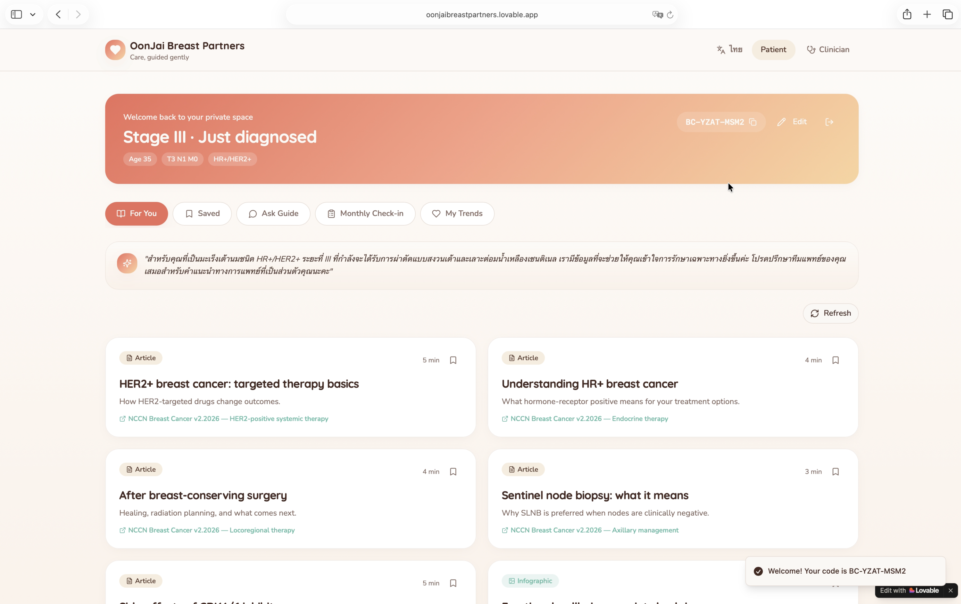
Figure 2 Previous version
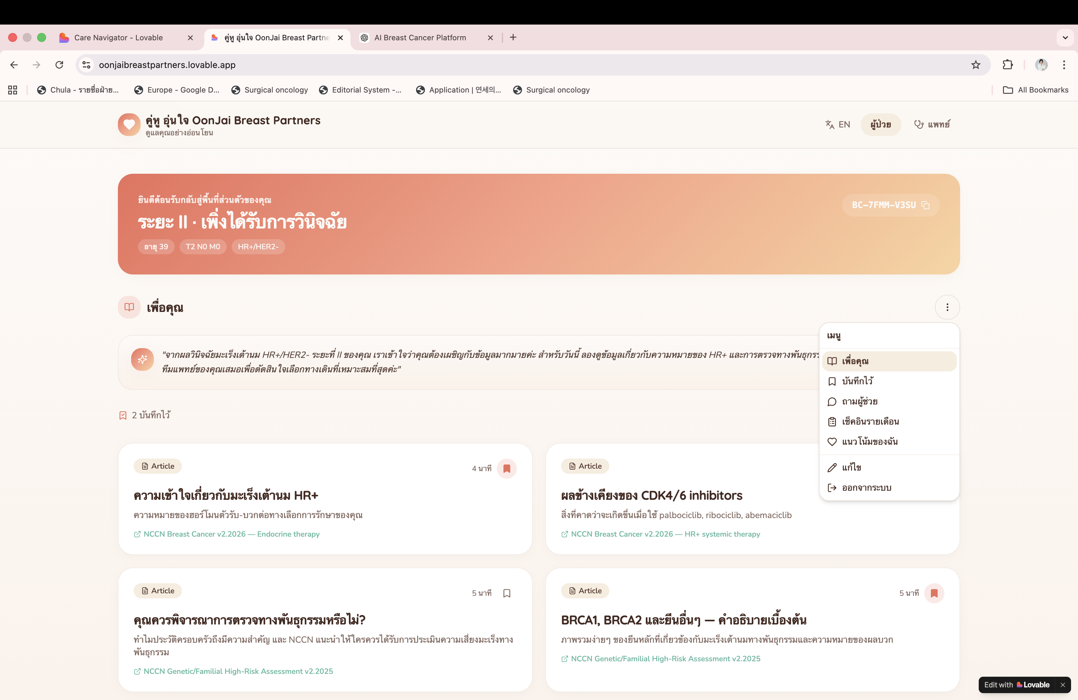
Figure 3 Current version
Reviewer 2:
Recommended including family history of breast, ovarian, and pancreatic cancer to enable personalized recommendations, particularly regarding genetic testing. (Figure 4 and 5)
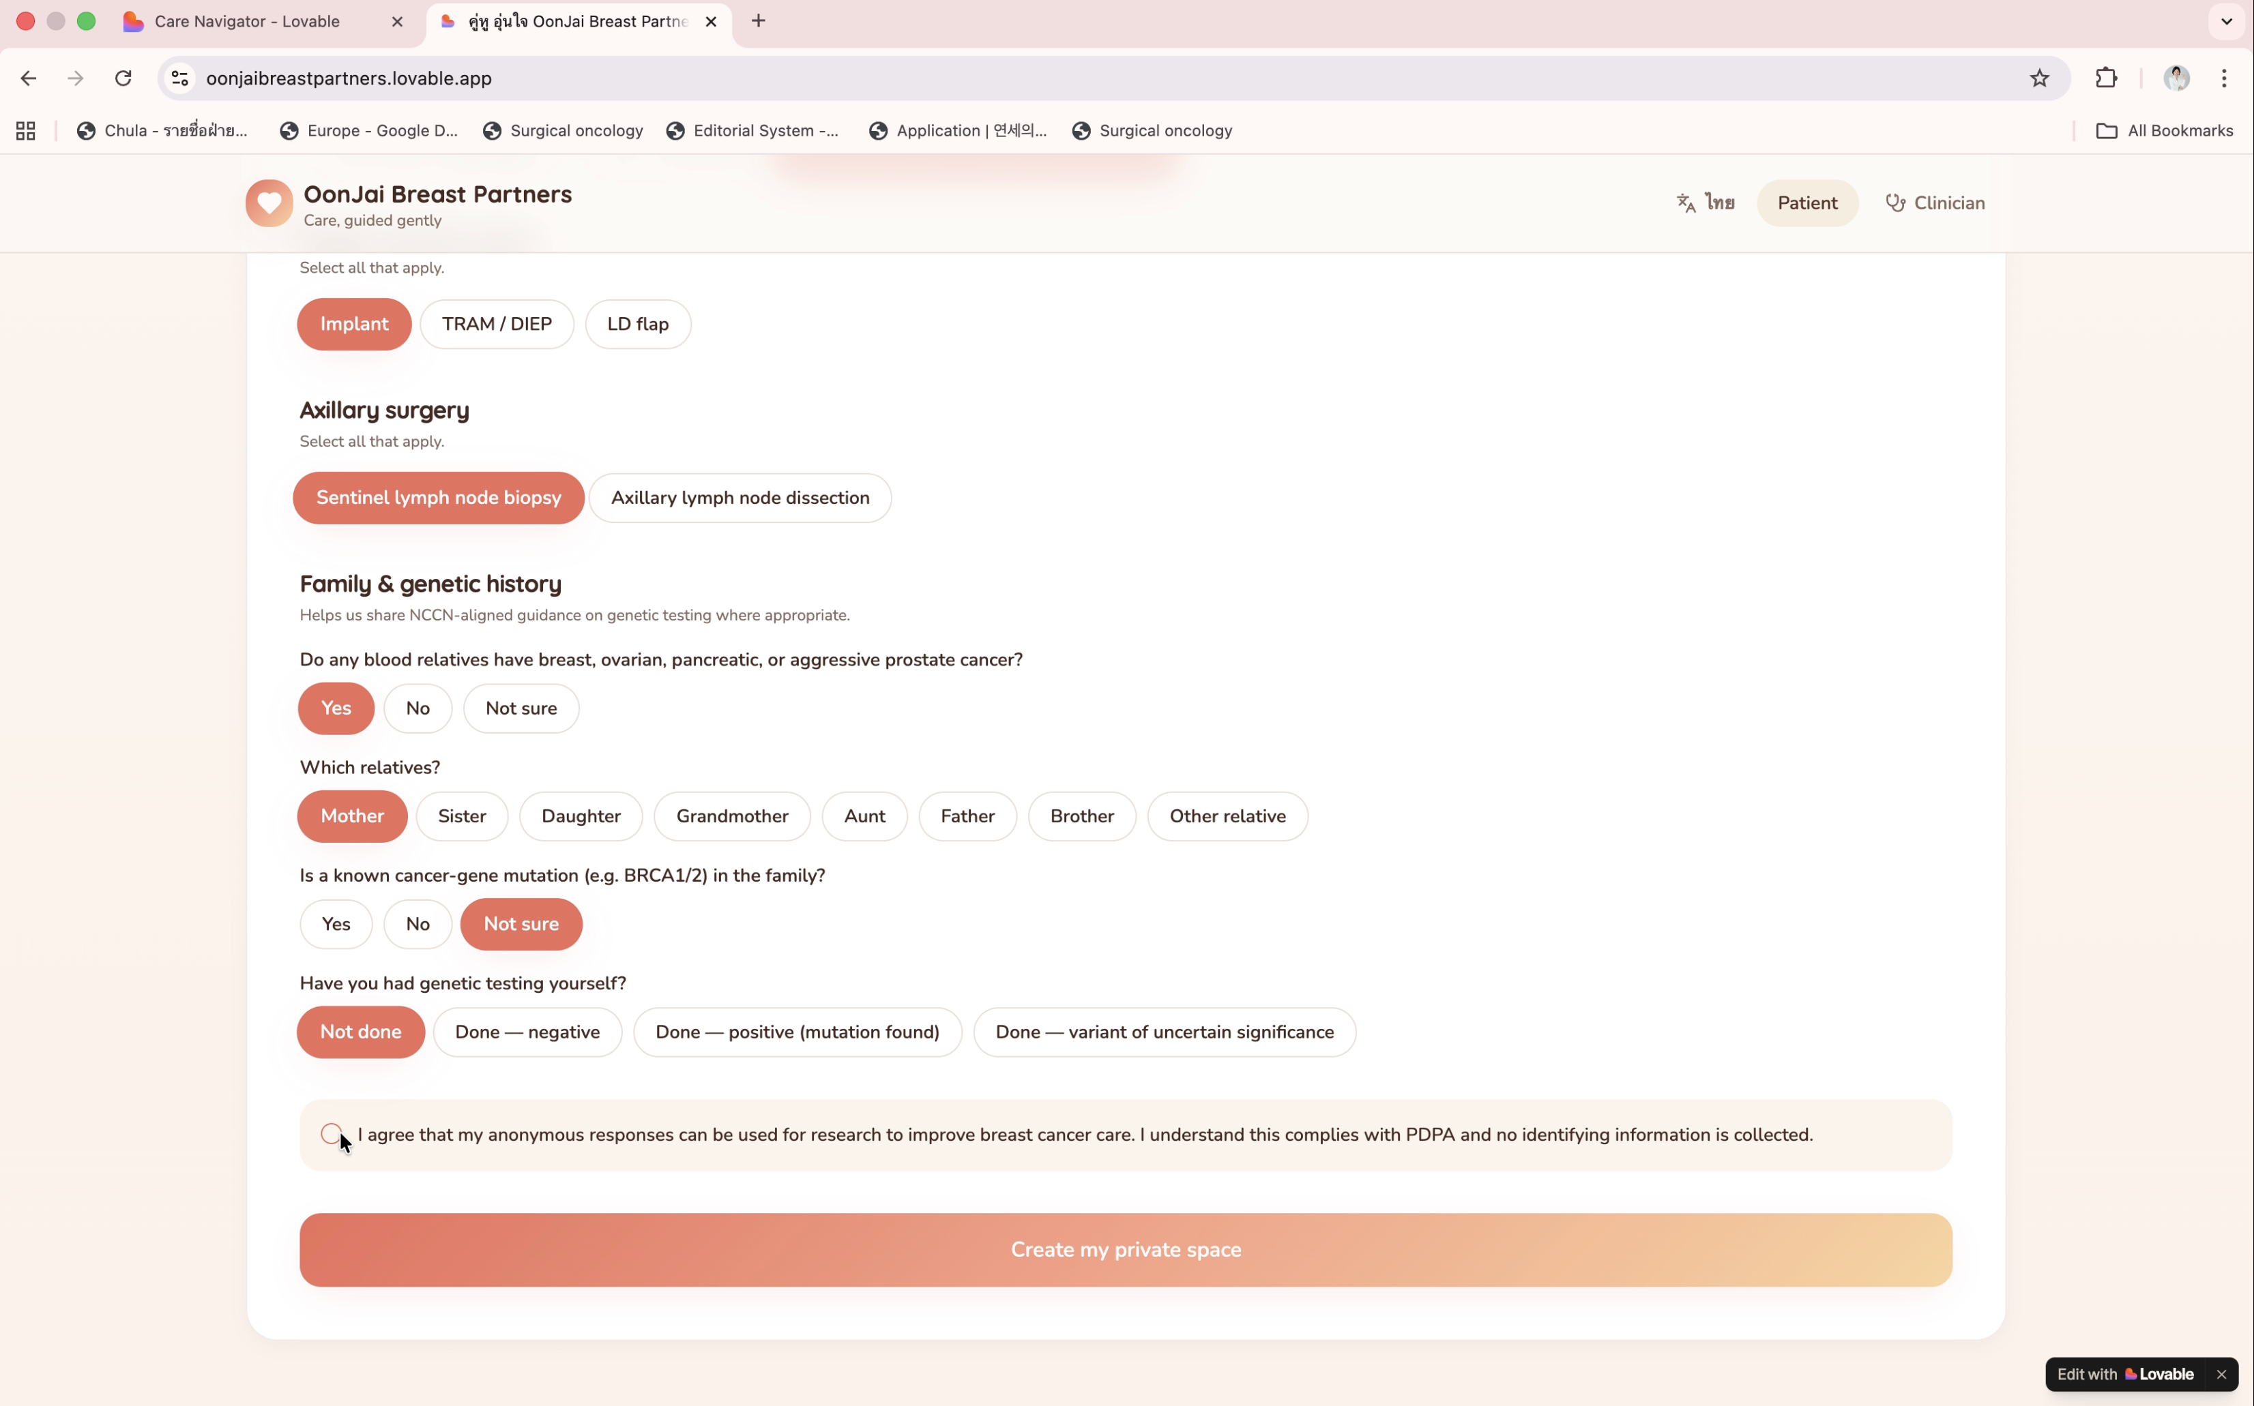
Figure 4 The registration including family history of breast, ovarian, and pancreatic cancer
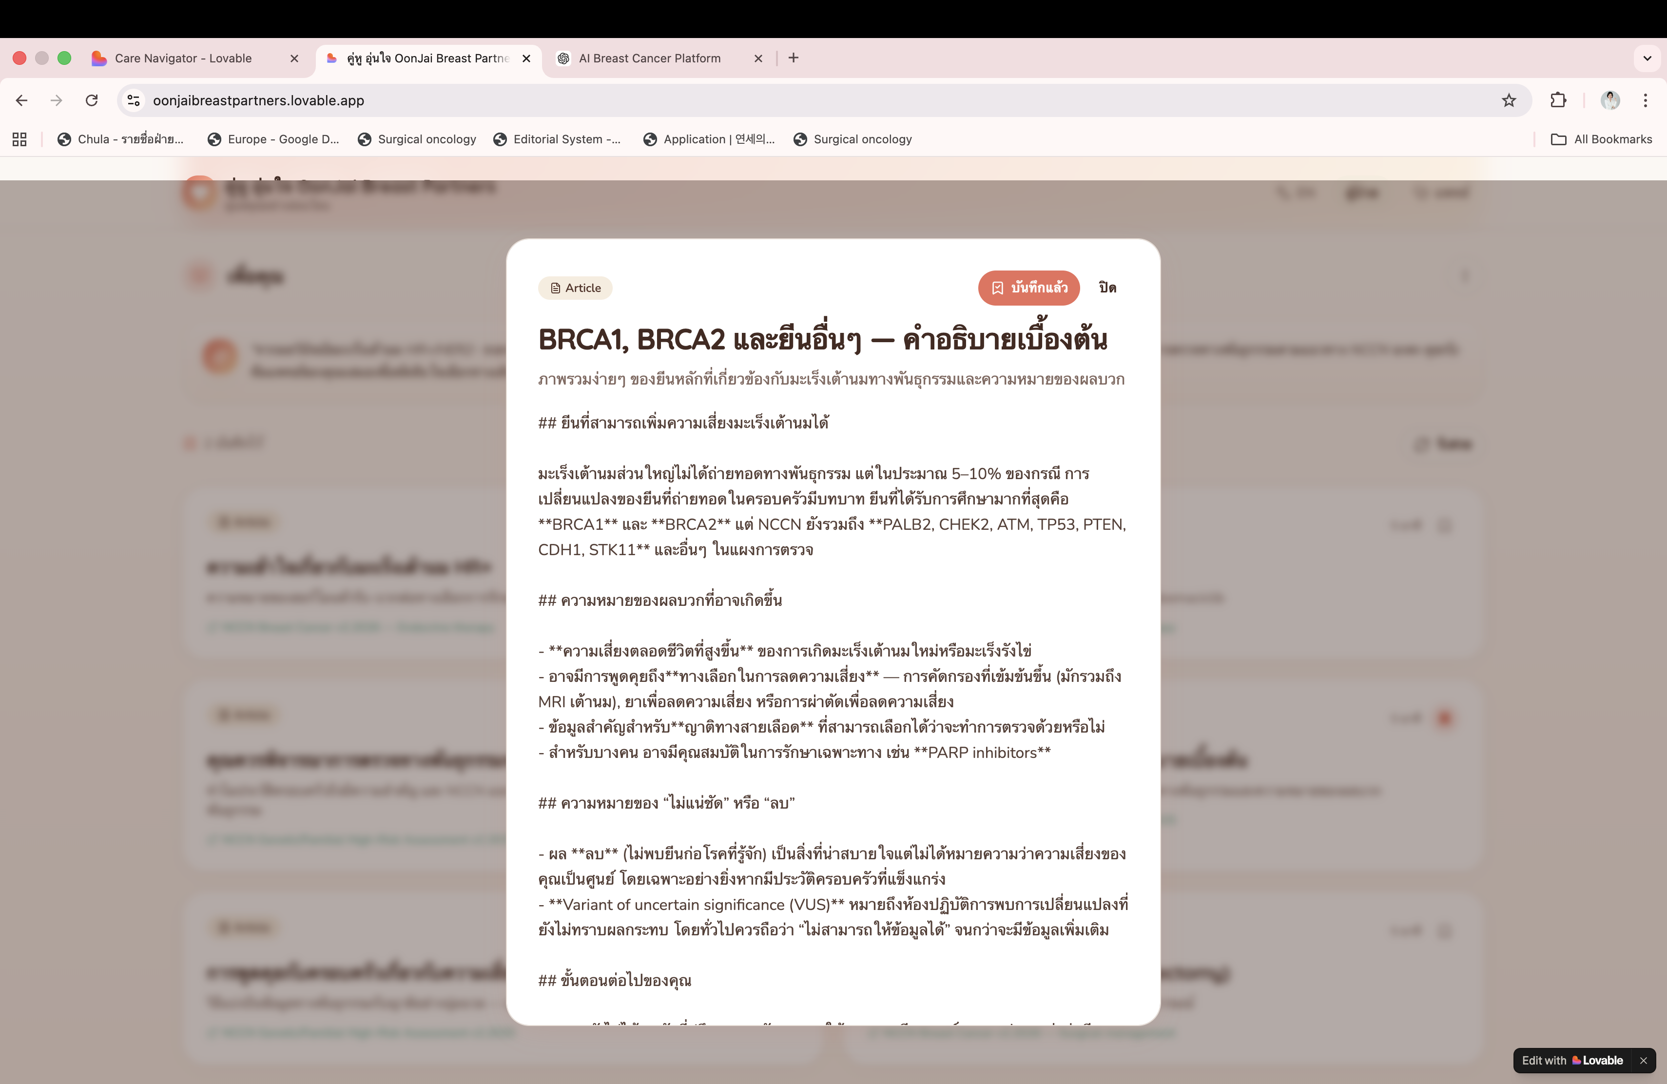
Figure 5 Customized content regarding BRCA mutation and multigene assays

8. Conclusion
This revised strategy analysis strengthens OonJai Breast Partners across all five dimensions highlighted in faculty feedback. The phased business model provides a clear, IRB-anchored research roadmap before scaling commercially. The diversified revenue structure reduces dependency on single-source sponsorship. The content partnership model defines specific collaboration structures with institutional safeguards. The user journey analysis quantifies where and how the platform intervenes to improve patient outcomes. And the competitive matrix demonstrates a defensible, differentiated position in the global digital oncology landscape.
If effectively implemented, OonJai Breast Partners can become Thailand’s leading breast cancer digital health platform—generating both meaningful patient impact and sustainable clinical research infrastructure.

OonJai Breast Partners | Chayanee Sae-lim, MD | Chulalongkorn University | 2026

